**N.KARTHIC** 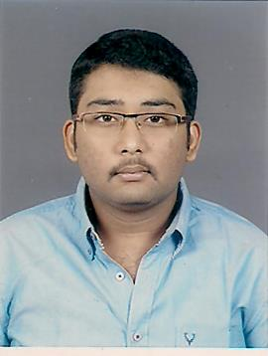 [**karthicking007@gmail.com**](mailto:karthicking007@gmail.com) 16A, Alagesan Road-2, +919585086383 SRP Nagar, Saibaba colony,

+919843649558 Coimbatore-641011

**CAREER OBJECTIVE:**

To work in an environment that gives me immense pleasure and satisfaction and make people in and around me feel happy and try to make my nation proud.

|  |  |  |  |  |  |
| --- | --- | --- | --- | --- | --- |
| **Course** | **Institution** | **Specialization** | **University / Board** | **Year of Passing** | **Marks in Percentage** |
| B.E | KGiSL Institute of Technology | Mechanical  Engineering | Anna University | 2014 | 70% |
| H.S.C | Stanes Anglo Indian  Higher Secondary School | Computer Science | Anglo Indian | 2010 | 70% |
| S.S.L.C | Stanes Anglo Indian Higher Secondary School | - | Anglo Indian | 2008 | 83.4% |

**ACADEMIC CHRONICLE:**

**AREAS OF INTEREST:**

* Automobile.
* Manufacturing.

**STRENGTHS:**

* Self motivated person.
* Punctuality.

**PROJECT DETAILS:**

1. **BAJA – SAE INDIA**

**Role :** Effective member.

1. **MINI PROJECT**

**Topic :** Gear Wrench Mechanism.

1. **MAIN PROJECT**

**Topic :** Compliant mechanism in Two Wheelers.

**EXTRA-CURRICULAR ACTIVITIES:**

* Effective Member of RRC ( Red Ribbon Club)
* Secretary of SAE ( Society of Automotive Engineers) Collegiate club.

**RESPONSIBILITIES UNDERTAKEN:**

* Organizer of SAMVIT’13 a national level technical symposium.
* Organizer of RIOGA’12 a national level technical Symposium.

**TECHNICAL EXPERIENCE:**

* Participant for Automotive Engine Management System Workshop of IIT Bombay, held in KGISL Institute of Technology.
* Undergone In plant training at ‘ACCUTECH’ in Coimbatore.

TRAINING UNDERGONE :

* Internship for 2 months at ‘SELENS LIFT COMPONENTS’, Coimbatore.
* Observation as TRAINEE in RABWIN INDUSTRIES (P) LTD, MALUMACHIMPATTY.

**HOBBIES:**

* Cricket and travelling.

**PERSONAL DETAILS:**

# Father’s Name : Mr.P.S.D.Nandha Kumar B.E (Served in LMW-Machine Tool Division for

# 25 Years)

# Father’s Number : 9843524474

Date of Birth : 20thSeptember 1992.

Gender : Male.

Marital Status :Single.

Nationality :Indian.

Languages Known :Tamil, English, Telugu.

**DECLARATION:**

I hereby acknowledge that all the information furnished herein is factually correct to the best of my knowledge.

**PLACE** : Coimbatore. **SIGNATURE**

D**ATE** : 17-11-15

